**Title (Capitalized, Arial 13)**

Name 1a Name 2,b and Name 3,*a

*a Author’s affiliation, City, Country.. b Author’s affiliation, City, Country.*

*\* E-mail address: 123@gmail.com*

**The abstract** should be completed in this template. The text of the abstract should describe the nature of the presenter’s oral or poster presentation, together with citations, if relevant. The text must be single-spaced, fully justified, and must use **11 pt Arial font.** The citations should be consecutively numbered as superscripts,[1] and should be detailed at the end using ACS format. Please do not deviate from the formatting outlined in this template; abstracts that deviate from this format will be returned for revision. **The entire abstract should not exceed one A4** **page**. This space can accommodate an abstract of approximately **350** words, a figure of the size shown below, and a couple of citations.

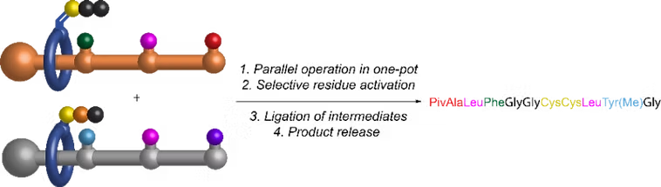

**Figure 1.** Illustration of xxxxx (**10 pt Arial font)**

Please send the abstract in both MS Word and PDF formats.

**References**

[1] Echavarren, J.; Gall, M. A. Y.; Haertsch, A.; Leigh, D. A.; Spence, J. T. J.; Tetlow, D. J.; Tian, C. *J. Am. Chem. Soc.* **2021**, *143*, 5158–5165.

**Biography of Speaker**

|  |  |
| --- | --- |
|  | Lorem ipsum dolor sit amet, consectetur adipiscing elit. Donec semper est ac libero ornare auctor. Nam eu venenatis diam. Nunc ac sapien metus. Sed efficitur lorem orci, ut ultricies velit varius ut. Sed vel ligula dignissim, hendrerit massa sit amet, consectetur odio. Nullam rhoncus rhoncus dictum. Cras mauris turpis, hendrerit ut urna ac, feugiat elementum nulla. Class aptent taciti sociosqu ad litora torquent per conubia nostra, per inceptos himenaeos. Donec et venenatis risus. In hac habitasse platea dictumst. Etiam blandit scelerisque massa hendrerit interdum. Quisque eu urna dapibus, bibendum lacus quis, elementum metus.  Fusce eu erat at nisi aliquet imperdiet id ut lorem. Vestibulum at lectus in urna tincidunt convallis. Interdum et malesuada fames ac ante ipsum primis in faucibus. Praesent porta suscipit ex, a auctor elit fringilla in. Suspendisse feugiat sem lacus, nec eleifend orci semper eget. Nam malesuada arcu ut semper tristique. Fusce magna nibh, hendrerit vel faucibus. (Please limit to 150 words) |
| **First Name**  **LAST NAME**  Organisation |